Friday, 22 March 2024

**Multithreading, Concurrency & Parallel programming**

**Why we even need multiple, both threads**.

The two main reasons we need threads for -

* Responsiveness
* Performance

**Responsivness**

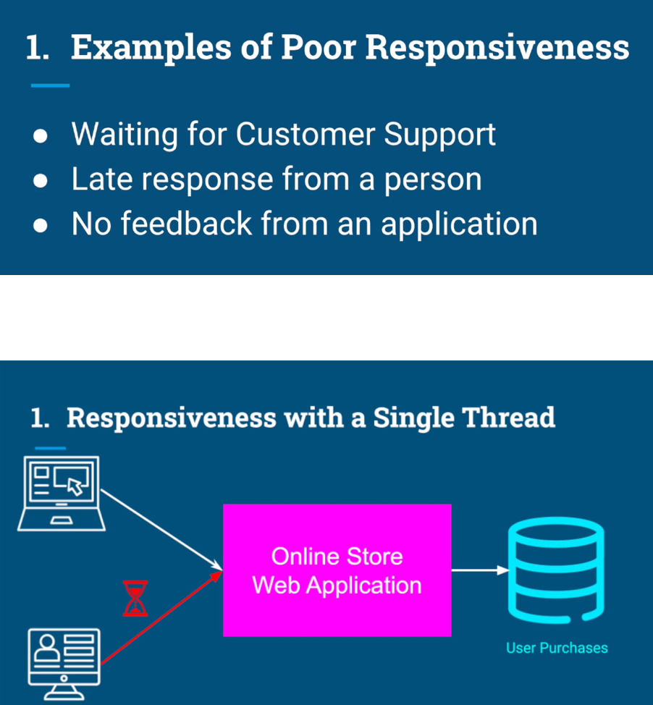

With multithreading we could actually serve multiple users simultaneously, but serving each request on a different thread.



Responsiveness is particularly critical when it comes to applications with a user interface. A good example for that can be a movie player application.

The application is showing us images, blamed the audio.

And in the same time, we expect that if we move the mouse or click

a button, we would get an instant feedback for our actions on the screen.



This kind of responsiveness can be achieved by using multiple threads,

each thread for a different task.

By multitasking quickly between different threads, Our computer can create an illusion that all those tasks are actually happening in the same time.

The term we use for this kind of multitasking is concurrency.

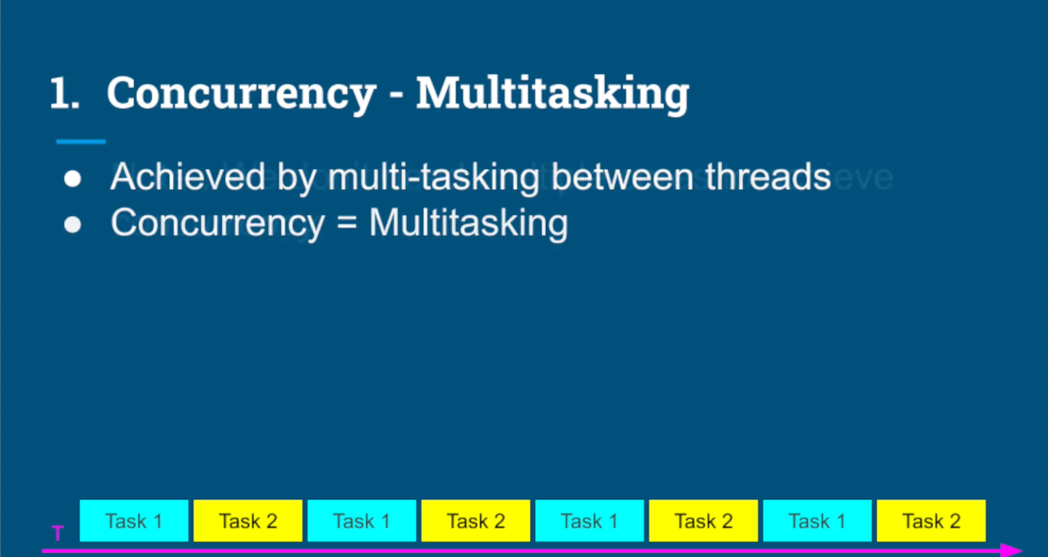

we don't even need multiple cores to achieve concurrency. Even with one core, we can create responsive applications by using multiple threads.

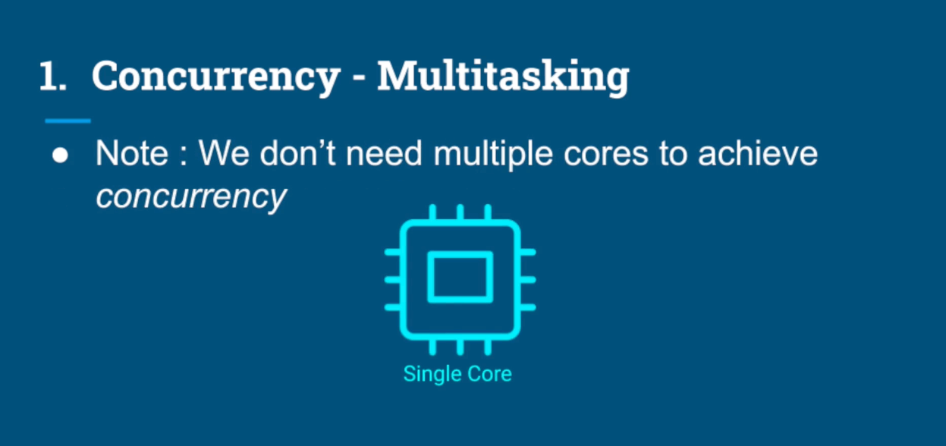

**Performance**

As mentioned before using concurrency, we can create an illusion of multiple

tasks running in parallel just with single core. With multiple core we can truly run multiple tasks completely in parallel.

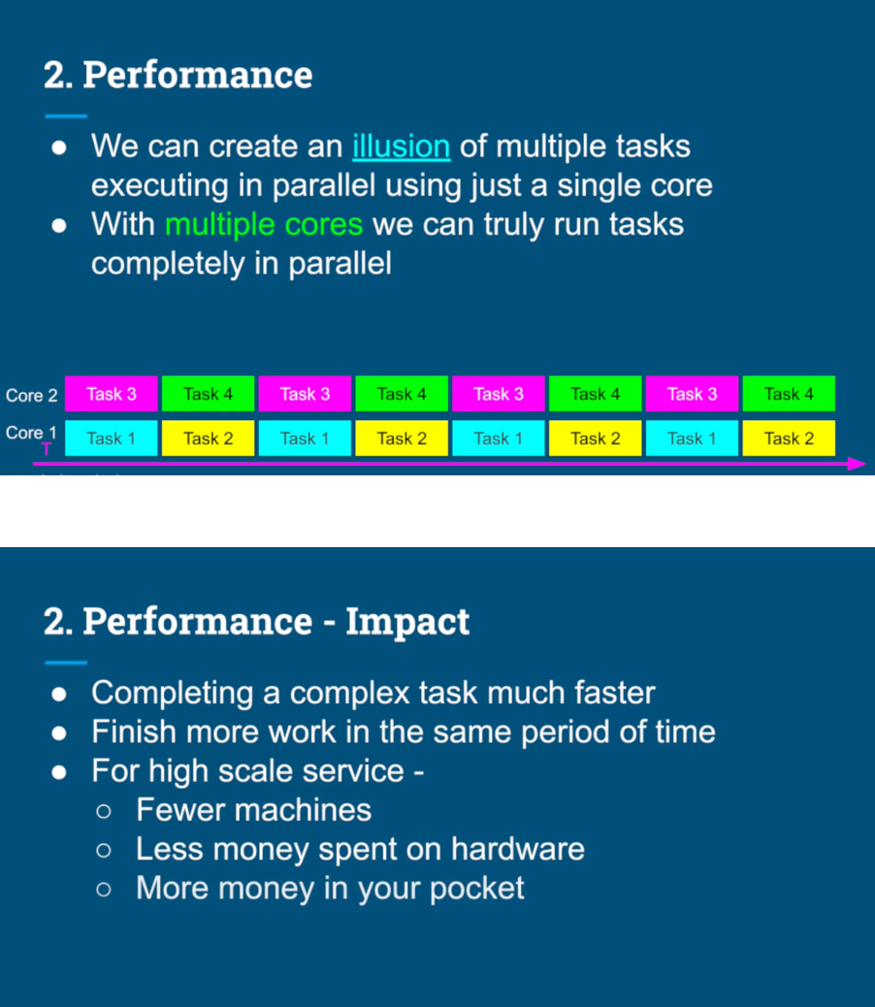

Responsiveness - Concurrency

﻿Performance - Parallelism